Compilation process for Project 5 including inserting new TBB library via terminal

Compilation process via the 2019 experimental version of TBB

Only one that I could get to work.

Link for 2019 experimental version

<https://packages.debian.org/experimental/armhf/libtbb-dev/download>

Next make command was use to compile the OpenMP code

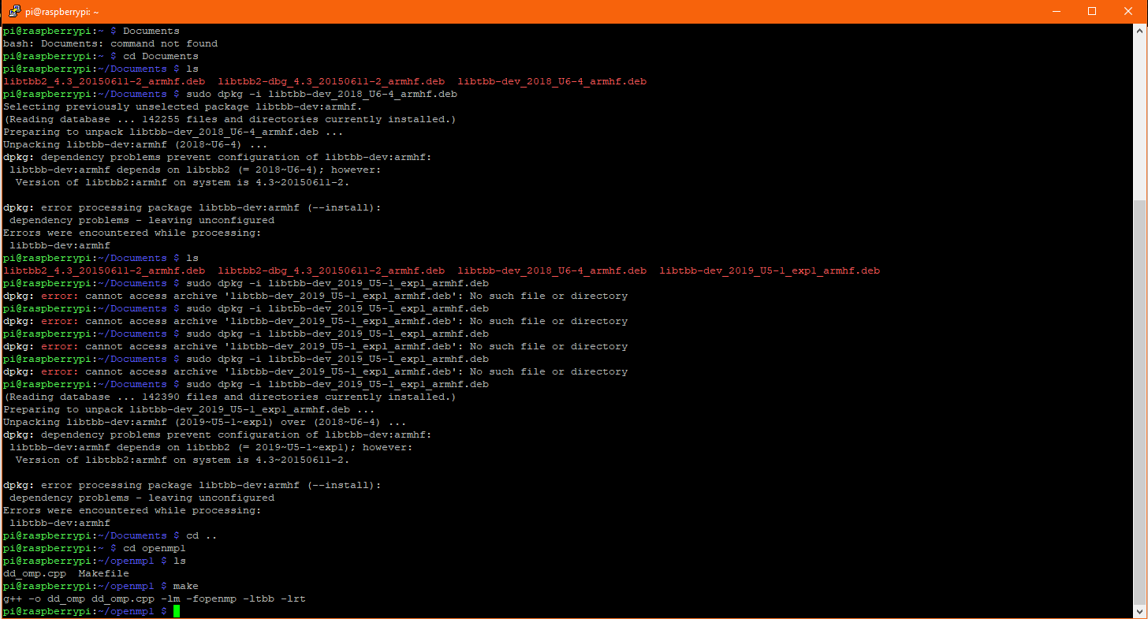

Compilation and run of serial version for ligands.

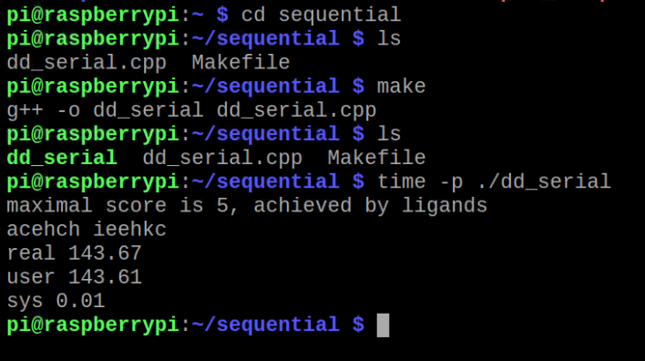

Compilation and run of first Threads code in cplusthreads1 directory.

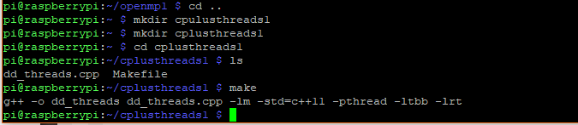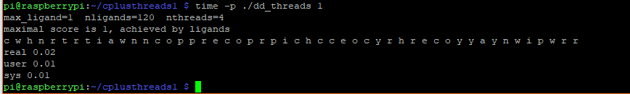

Questions for last project DNA with ligand comparisons

1. The omp and pThreads implementations are both similar in overall speed in regards to ligand comparisons.

2. We can see that the pThreads implementation is only 14 more words in the code which really equates to only a couple of lines of code.

Pthreads = 207

OpenMP = 193

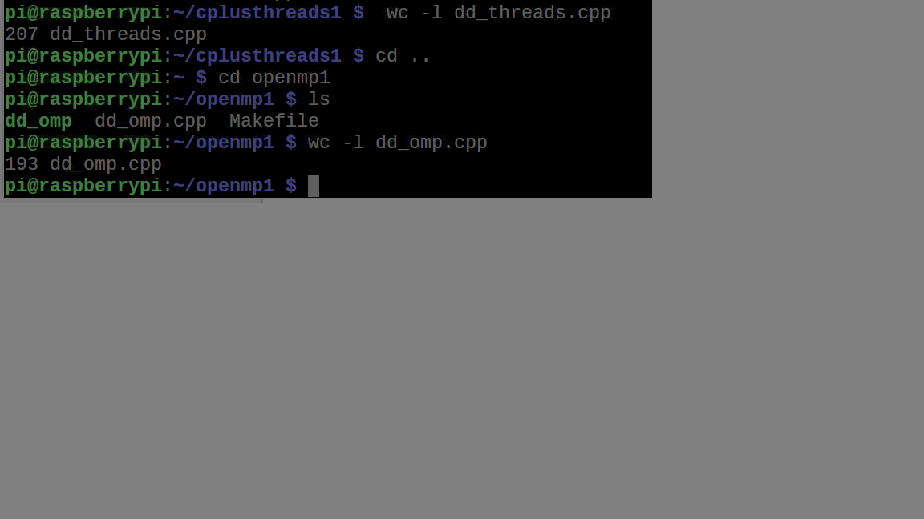

3. Using a max ligand match length of 4 and number of processing threads as 5. Threads time was 0.21 and OMP code time was 0.21

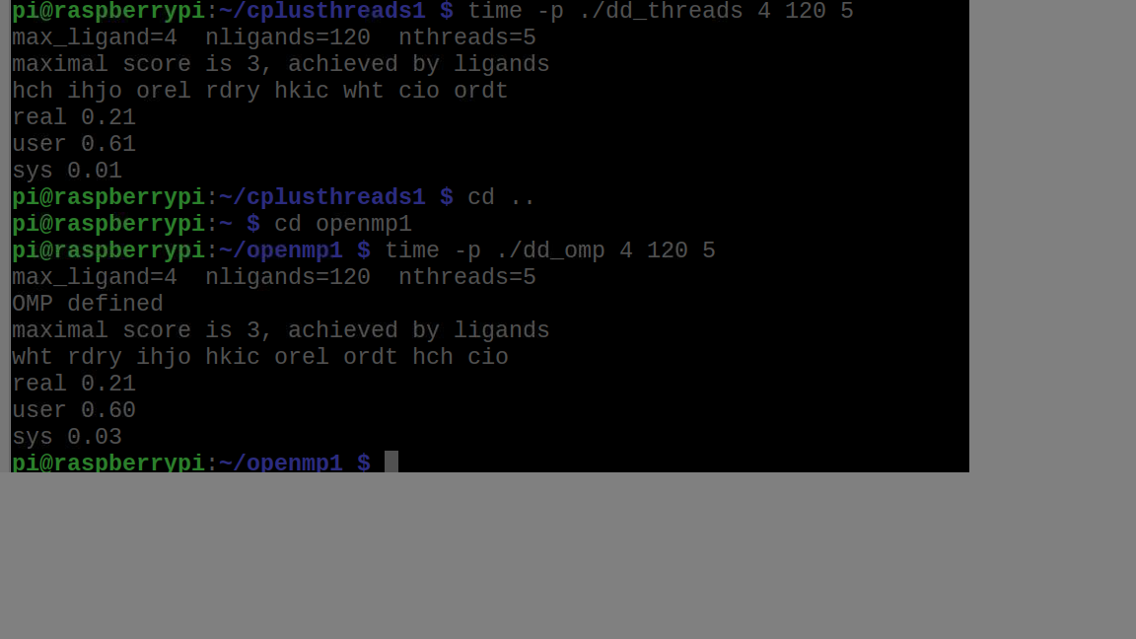

4. Using the number of threads as 4 and the max ligand length of 7 we get OMP time of 80.83 and a Threads time of 42.46.

Max threads 4

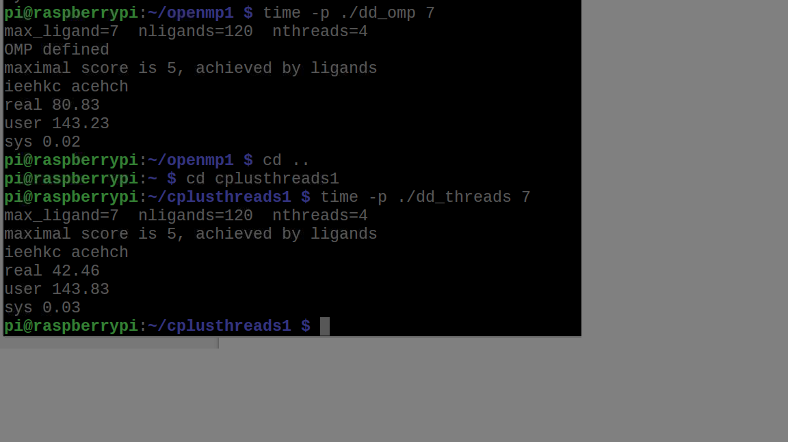

Max threads 5 w/ligand 7

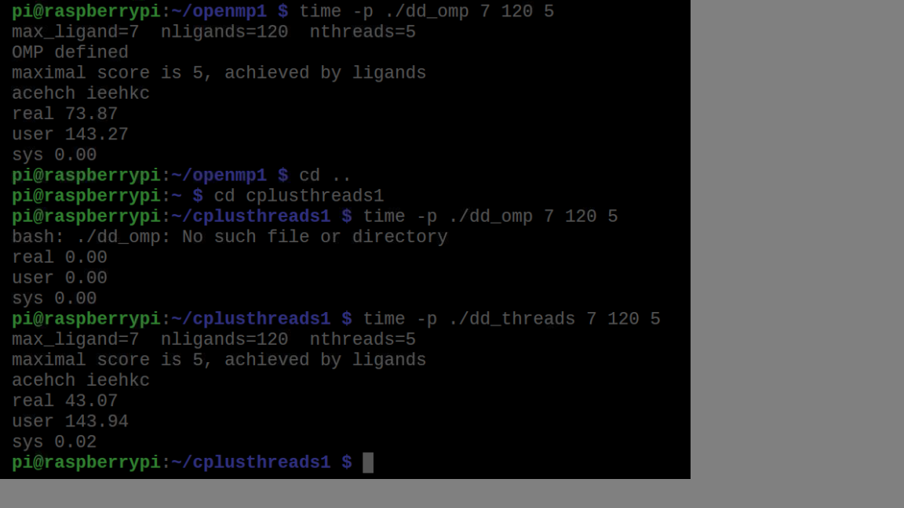

Using the number of threads as 5 and the max ligand length of 7 we get OMP real time of 73.87 and a Threads code real time of 43.07.

Tables comparing times

|  |  |
| --- | --- |
| Implementation | Time (s) real |
| dd_serial | 143.67 |
| dd_omp 1 ligand | 0.03 |
| dd_threads 1 ligand | 0.02 |

|  |  |  |  |
| --- | --- | --- | --- |
| Implementation | Time(s) 2 ligands Threads | Time(s) 3 ligands Threads | Time(s) 4 ligands Threads |
| dd_omp | 0.02 | 0.06 | 0.25 |
| dd_threads | 0.02 | 0.06 | 0.21 |